 | LAKELAND SENIOR HIGH SCHOOL SCIENCE DEPARTMENT  YEAR 11 HUMAN BIOLOGY GENERAL  UNIT 2 – Reproduction  Reproductive Technologies and Sexually Transmitted Diseases  PART B: Short Answers
Student Answer Booklet
Multiple choice |  | /12 | Student Name:
Short answer |  | /37 | Teacher:
TOTAL |  | /49 | Date:
SECTION A – MULTIPLE CHOICE ANSWERS (10 marks)
Put a cross(X) through your choice of answer. If you make a mistake, scrub out your answer, then select a new one. Complete ALL short answer questions in the spaces provided.

1. |  |  |  | b |  |  |  |  |  |  |  | 6. |  |  |  |  |  | c
2. |  |  |  |  |  | c |  |  |  |  |  | 7. |  |  |  |  |  |  |  | d
3. |  |  |  |  |  |  |  | d |  |  |  | 8. |  |  |  | b
4. |  | a |  |  |  |  |  |  |  |  |  | 9. |  |  |  | b |  | c
5. |  |  |  | b |  |  |  |  |  |  |  | 10. |  |  |  |  |  | c
 |  |  |  |  |  |  |  |  |  |  | 11. |  |  |  |  |  |  |  | d
 |  |  |  |  |  |  |  |  |  |  |  | 12. |  | a

SECTION B – SHORT ANSWER (35 marks)
- State three main factors affecting fertility in a male and a female:
Causes of Infertility
Male | Female
- volume concentration,  - motility,  - morphology | - Ovulatory (eg when a woman does not release an egg every month; poor egg quality)  - Tubal - tubal blockage (eg STI’s / Pelvic Endometriosis)  - Age
(6 marks)
- Complete the following table:

STI | Caused by which organism? | Early Symptoms | Treatment(s)
Gonorrhoea | BACTERIA | MALES: YELLOW PUS,  BURNING WHEN URINATING, 2-10 DAYS OF INFECTION  FEMALES: NO SYMPTOMS, OR PAINFUL URINATION/CLOUDY URINE, VOMITINE, DIARRHOEA | ANTIBIOTICS
Genital Warts | VIRUS [HPV] | SOFT MOIST WARTS, SINGLE OR CLUSTERS  APPEAR 6-8 MONTHS AFTER INFECTION. | ANTI-VIRALS  REMOVAL OF WARTS
Genital Herpes | VIRUS | ITCHING BLISTERS FILLED WITH FLUID, FLU-LIKE SYMPTOMS, | NONE, CAN ONLY BE TREATED [ANTI-VIRALS]
Chlamydia | BACTERIA | FEMALES: OFTEN ASYMPTOMATIC,  MALES: PAIN/BURNING WHEN URINATING, YELLOW DISCHARGE, | ANTIBIOTICS

(12 marks)

- What is the difference between HIV and AIDS?
HIV is a virus that can lead to immune system deterioration. The term “HIV” stands for human immunodeficiency virus that attacks the human immune system.
AIDS (which is short for acquired immunodeficiency syndrome) is the condition developed in the later stages of contracting the HIV virus.
(2 marks)

15. There are a number of reproductive technologies available for couples who have been considered infertile.
a. What is the difference between the terms sterile and infertile?
STERILE – IS THE PERMANENT IRREVERSIBLE INABILITY TO HAVE CHILDREN
INFERTILE- INABILITY TO CONCEIVE A CHILD AFTER 1 YEAR OF REGULAR SEXUAL INTERCOURSE

(2 marks)
b. Two technologies th at are available are called GIFT and ZIFT. How are they SIMILAR to each other? How are they DIFFERENT to each other?
BOTH TRANSFER THEIR “PRODUCT” INTO THE FALLOPIAN TUBE (1)
ZIFT= EGG IS FERTILISED IN A TEST TUBE THEN THE ZYGOTE IS TRANSFERRED INTO Fallopian tube (1)
GIFT= EGG AND SPERM (GAMETES) ARE INTRODUCED INTO FALLOPIAN TUBE (1)

(3 marks)
c. State two impacts that aging has on a woman’s fertility
- The total number of eggs in their ovaries declines
- Risk chromosomally abnormality increases which reduces the chance of pregnancy and increases the risk of miscarriage
- higher risk of disorders that can affect fertility, such as uterine fibroids and endometriosis

(2 marks)

16. The graph on the next page is incomplete. It shows the number of people who contracted gonorrhoea or chlamydia in 2016.
a) Complete the graph by labelling the axis and adding an appropriate title. (3 marks)
- “THE NUMBER OF PEOPLE WHO CONTRACTED GONORRHOEA OR CHLAMYDIA IN 2016”
- X-axis: AGE GROUP (YEARS)
- Y-axis: NUMBER OF PEOPLE
b) What is the independent variable? GONORRHOEA & CHLAMYDIA (1 mark)
c) What is the dependent variable? AMOUNT OF PEOPLE WHO CONTRACTED THE DISEASE (1 mark)
d) Name two (2) variables that were kept the same.
SAME NUMBER OF MALES AND FEMALES
SAME NUMBER OF PEOPLE IN EACH AGE GROUP
(2 marks)

e) Which age group has the highest cases of females with chlamydia? 20-24 YRS (1 mark)
f) Why do females have more cases of chlamydia than males?
FEMALES USUALLY HAVE NO SYMPTOMS (1)
MALES WILL HAVE SYMPOMS MUCH EARLIER AND SEEK TREAMENT (1)
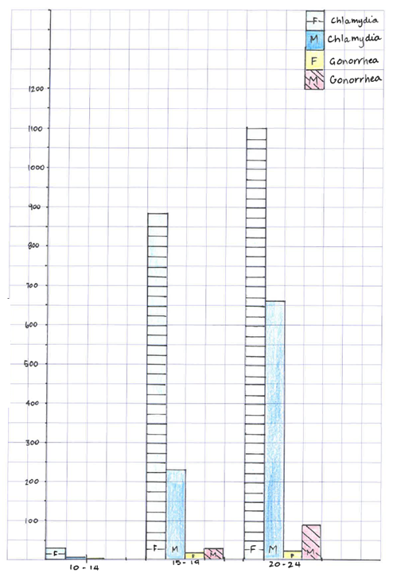
END OF TEST

